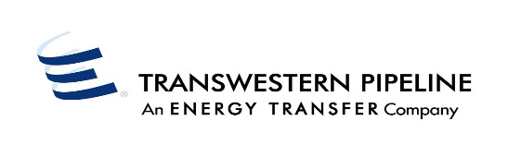 Timely
Evening
Intraday 1
Intraday 2
Contract Number: (only one contract per page) |  |  |  |  |  | Today's Date: |  |  |  |  |  | Prepared By:
Shipper: |  |  |  |  |  |  |  |  | Telephone:
Agent For: |  |  |  |  |  |  |  |  | Fax No.:
* ALL FIELDS BELOW DESIGNATED WITH AN ASTERISK ARE MANDATORY
MINATION DATE |  |  |  |  |  |  | RECEIPT INFORMATION |  |  |  | DELIVERY INFORMATION
*BEGIN  DATE | *END  DATE | POOL BASIN | *LOCATION | *UP  K# | *UP ID | *QUANTITY (DTH) | RANK | *LOCATION |  | *DOWN K# | *DOWN ID |  | *QUANTITY (DTH) | RANK | TRANS TYPE | PACKAGE ID | FUEL |  | **TW HUB 1st UPSTRM | **TW HUB LAST DNSTRM
Intraday 3
Final AM
Attn: Market Services Rep:________________________________________________________
TRANSPORTATION NOMINATION
** These are additional data fields that are only applicable for nominations related to Northwest Pipeline HUB.
TW_Nomination_Fax_Form

