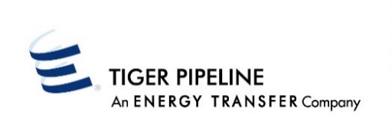

Timely
Evening
Intraday 1
Intraday 2
Intraday 3
Final AM
ATTN Market Services Rep:-______________

Please fax Confirmations to: Attn: Market Services
Fax No: (713) 989-1203

OPERATOR CONFIRMATION
OPERATOR NAME: |  |  |  |  |  |  | TODAY'S DATE: |  |  | PREPARED BY:
OPERATIONAL BALANCING AGREEMENT NUMBER: |  |  |  |  |  |  | TELEPHONE NUMBER: |  |  | FAX NUMBER:
BEGIN DATE | END DATE | LOCATION | LOCATION NAME | FLOW IND  (R) (D) | UP/DN ID | UP/DN K# |  | SVC REQ K# | SERVICE REQUESTER | SVC REQ ID |  | CONF QUANTITY | MAKEUP QUANTITY | REDUCTION REASON CODE
Revised 2/1/18

